June 2023 – for immediate release

Renishaw’s new manufacturing data platform showcases smart factory automation at EMO Hannover 2023

Global engineering technologies company, Renishaw, will demonstrate its new manufacturing connectivity and data platform at EMO Hannover 2023. Renishaw Central is a data-driven solution designed to transform the productivity, capability and efficiency of manufacturing operations.

Bringing the power of connectivity to the machine shop floor, the system collects accurate, actionable data on machines, parts and processes from across the factory, and presents it centrally for insight and interrogation at the point of manufacture.

The Renishaw Central platform provides machine shop connectivity, consistency, control and confidence. It allows manufacturers to harness end-to-end process data and use it to develop a robust factory-wide system architecture.

The platform enables you to monitor and update machining and quality control systems. Manufacturing process parameters can also be updated using its unique and patented Intelligent Process Control (IPC) software functionality. The ability to predict, identify and correct process errors before they happen supports increasingly automated solutions and processes for long-term productivity, capability and efficiency gains.

“The Renishaw Central concept was born out of our own need to digitalise, visualise and control the manufacturing and measurement processes within our own production facilities. We wanted to reduce assumptions when problem solving, and facilitate the adoption of automated process control,” said Guy Brown, Renishaw Central Development Manager. “Because we live and breathe many of the same challenges faced by our customers, we’re confident that we’ve created a digital solution capable of driving actionable data across machining shop floors everywhere.”

Renishaw has used process automation technologies in the manufacture of its own products for over 30 years. During its in-house design and development, the Renishaw Central platform was deployed in the UK at Renishaw’s own low-volume high-variety manufacturing facilities at Miskin and Stonehouse. 69 machines were connected to Renishaw Central, and both sites subsequently reported a reduction in unplanned machine downtime caused by automation system stoppages.

Collaboration with those working directly with Renishaw Central in the machine shop, including production engineers, and maintenance and operations staff, allowed Renishaw to engineer a product that solves real-world problems. “Our original aim for Renishaw Central was to introduce further automation for lathes using our IPC technology, and this is progressing well. But an unexpected and positive outcome has been Renishaw Central's ability to highlight and rank unplanned stoppages of our automation systems,” said Guy. “Analysis of this information has guided remedial actions, leading to a 69% reduction in automation stoppages and significant improvements in utilisation.”

A global selection of pilot customers who trialled Renishaw Central also confirmed that access to standardised end-to-end data provided an insight into their processes that has allowed them to improve manufacturing performance.

Renishaw Central collects and provides visibility of machining process data across the factory for insights at the point of manufacture. With Renishaw Central, manufacturers can check the performance of devices on the shop floor, understand device utilisation, and examine and validate part quality. User-friendly dashboards show live device data. Data can be passed into industry-leading tools such as Microsoft® Power BI via APIs. Data analytics can then be used for in-process control applications and continuous improvement.

For further information on how Renishaw Central could support the digitalisation and control of your end-to-end manufacturing processes, visit us at EMO Hannover, Germany (18-23 September 2023, stand B32 hall 6)

Video: http://mediacentre/details/321699

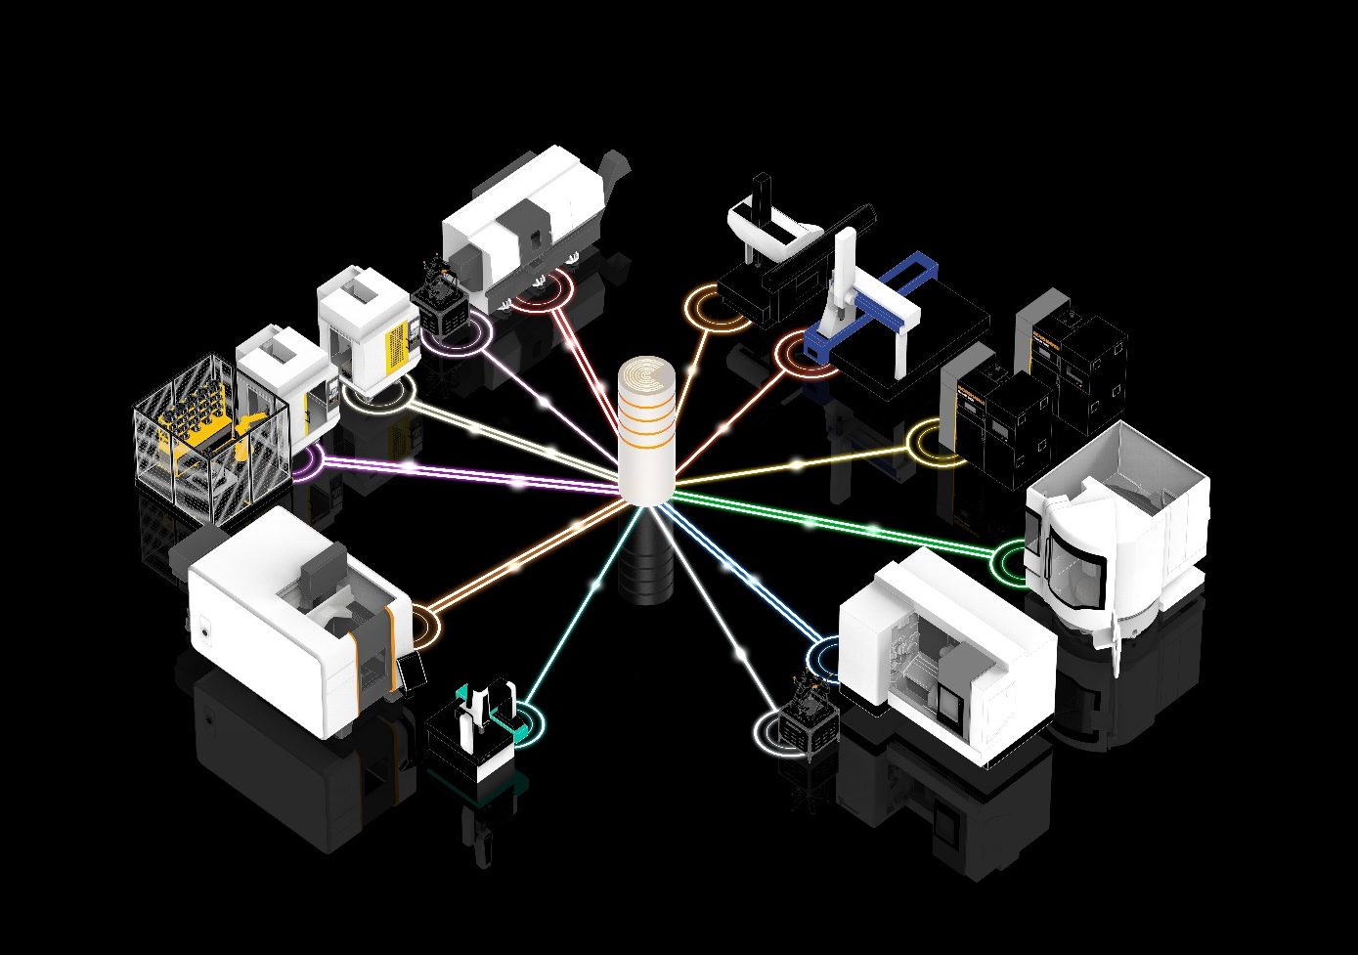Renishaw Central is an on-premises platform which provides real-time data from connected machines and devices.
Renishaw Central provides a factory-wide view of your manufacturing data.

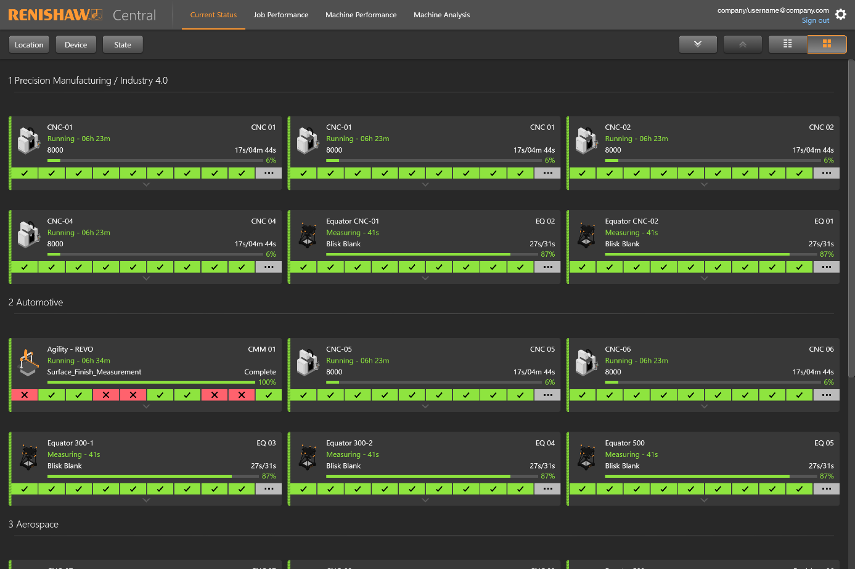
Renishaw Central web browser views allow live data to be displayed, sorted, filtered and plotted.

-ENDS-

Notes to editors

Renishaw is a world leading supplier of measuring systems and production systems. Its products give high accuracy and precision, gathering data to provide customers and end users with traceability and confidence in what they’re making. This technology also helps customers to innovate their products and processes.

It is a global business, with over 5,000 employees located in 36 countries where it has wholly owned subsidiary operations. The majority of R&D work takes place in the UK, with the largest manufacturing sites located in the UK, Ireland and India.

For the year ended June 2022 Renishaw recorded sales of £671.1 million of which 95% was due to exports. The company’s largest markets are China, USA, Japan and Germany.

Renishaw is guided by its purpose: Transforming Tomorrow Together. This means working with customers to make the products, create the materials, and develop the therapies that are going to be needed for the future.

Further information at www.renishaw.com

