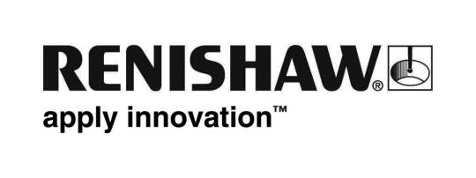
27th March 2012 – for immediate release Enquiries: Chris Pockett (+44 1453 524133)

Renishaw nominated for national Investor Relations award
Renishaw, the FTSE 250 listed global engineering company, and its Head of Communications Chris Pockett, have been nominated for the ‘Best Investor Relations Communications’ Award at the UK Stock Market Awards taking place on Thursday 29th March at the Honourable Artillery Company in London.
The awards aim to celebrate ‘all that is great about UK PLCs’ and identify the best performing stock market listed companies in a range of market sectors based on their implementation of a carefully considered strategy to properly balance risk with return and create shareholder value.
The Best Investor Relations Communications award recognises companies which have most effectively disseminated information on all aspects of their financial performance, strategy and market positioning to existing and potential shareholders. An independent panel of judges of equity market participants and commentators will consider activities across the full range of media, from official RNS (regulatory news service) press releases and annual reports, to a company’s website and via their public relations representative.
Chris Pockett, Renishaw’s Head of Communications, said, “We were very pleased, although a little surprised to be nominated for the IR communications award considering the many blue-chip companies listed on the London Stock Exchange. It would appear that shareholders and financial analysts like our approach to communications, in which we always try to give a real sense of the personality of Renishaw and a modern manufacturing business, beyond simply the numbers.
“Therefore we are always keen to give people tours of our facilities in Gloucestershire, including shareholders who attend our AGM, plus we get positive feedback from the investor community about our regular company news emails and blog.”
Other companies/individuals nominated for the Best Investor Relations Communications award are Melrose (Garry Barnes), the Weir Group (Vicky Ferrier), IP Group (Liz Vaughan-Adams) and the Pennon Group (Jo Finely).
Ends

