June 2018
Scientists from The University of Manchester team up with Renishaw to analyse tissue
Renishaw has collaborated with scientists at The University of Manchester to show the ability of Raman spectroscopy to analyse skin tissue. This work was presented at the recent Joint Meeting of the Symposium on Advanced Wound Care and the Wound Healing Society, held in Charlotte, North Carolina, USA, from 25-29 April, 2018.
Miss Rubinder Basson and her supervisor, Dr Ardeshir Bayat, from the Division of Musculoskeletal and Dermatological Sciences, at The University of Manchester, gave a talk titled ‘A novel sequential multi-tiered in vivo approach for quantitative evaluation of topicals for treatment of human skin scarring’. This work shows the ability of Raman spectroscopy—using Renishaw’s Biological Analyser—to analyse skin tissue, track the transdermal delivery of a skin wound healing drug, and elucidate the tissue healing biochemical changes taking place.
Rubinder and Ardeshir also presented a poster titled: ‘Raman spectroscopy and HPLC: in vivo and ex vivo validation of a combi-approach for testing transdermal delivery of compounds in wounds and scars’. They proposed a new combined approach to the assessment of transdermal delivery of topicals; initially using ex vivo human skin culture with high performance liquid chromatography (HPLC), and subsequent validation by Raman spectroscopy of in vivo normal and scarred skin. This dual approach successively showed successful detection, as well as measurement, of exact depth of penetration of compounds following the application of a topical formulation in cutaneous scar tissue in both ex vivo and in vivo models.
Renishaw’s Biological Analyser enables the imaging of whole skin tissue sections using LiveTrack focus tracking technology and collects high quality spectral datasets for analysis. Find out how Renishaw’s Raman instruments can be used for biological research by visiting www.renishaw.com/bio
More information about the Symposium on Advanced Wound Care, the world’s leading, largest, and most well-respected interdisciplinary wound care program within the clinic field, can be found at www.sawc.net/spring
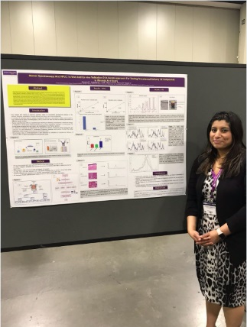
Image: Rubinder Basson with her poster at the Joint Meeting of the Symposium on Advanced Wound Care and the Wound Healing Society.
-ENDS-

About Renishaw

Renishaw is one of the world's leading engineering and scientific technology companies, with expertise in precision measurement and healthcare. The company supplies products and services used in applications as diverse as jet engine and wind turbine manufacture, through to dentistry and brain surgery. It is also a world leader in the field of additive manufacturing (also referred to as 3D printing), where it is the only UK business that designs and makes industrial machines which ‘print' parts from metal powder.

The Renishaw Group currently has more than 70 offices in 35 countries, with over 4,500 employees, of which 3,000 people are employed within the UK. The majority of the company's R&D and manufacturing is carried out in the UK and for the year ended June 2017 Renishaw achieved sales of £536.8 million of which 95% was due to exports. The company's largest markets are the China, USA, Germany and Japan.

The Company's success has been recognised with numerous international awards, including eighteen Queen's Awards recognising achievements in technology, export and innovation. Renishaw received a Queen’s Award for Enterprise 2014, in the Innovations category, for the continuous development of the inVia confocal Raman microscope. For more information visit www.renishaw.com

For further information

Please contact:
David Reece
Renishaw plc
New Mills
Wotton-under-Edge
Gloucestershire GL12 8JR UK
Tel: +44 1453 523968 (direct)
Tel: +44 1453 524524 (switchboard)
Fax: +44 1453 523901
Email: david.reece@renishaw.com
www.renishaw.com/raman

